QForm
The source data required for simulation
Date
Company
Country
Project name
Contact person responsible for the project:
Name |  | Position
E-mail |  | Telephone
Fax |  | Skype
Expected results of simulation
For more qualitative preparation of the simulation’s report it is necessary to know what kind of result you want to get:
Material flow pattern and prediction of laps, folds, flow-through defects and
Estimate force or energy of deformation
Present temperature, mean stress, effective stress, strain, strain-rate distributions or their values in specific points
Stress, deflection, wear of the tools
Any other parameters:

Operation 1
Process parameters
Process type |  | General forming/Cooling/Heating
Workpiece parameters
Material |  | Standard
Initial temperature
Tool parameters
Equipment type
Tool material |  | Standard
Lubricant
Temperature
Stop condition*
Distance between tools, mm
Process time, sec
Tool stroke, mm
Final position (like in geometry file)
Maximum load, МN
Rotation the tool around axis, deg

Number of blows | (for hummer forging)
Type of the attached file
2D (axisymmetric, plane) | 3D (full geometry or sector)
dxf | STEP | IGES

* – simultaneously you may specify several conditions of the simulation stop. In such a case the simulation is stopped when any one of them has been fulfilled.
Operation 2
Process parameters
Process type |  | General forming/Cooling/Heating
Workpiece parameters
Material | Inherit | Standard
Initial temperature | Inherit
Tool parameters
Equipment type
Tool material |  | Standard
Lubricant
Temperature
Stop condition *
Distance between tools, mm
Process time, sec
Tool stroke, mm
Final position (like in geometry file)
Maximum load, МN
Rotation the tool around axis, deg

Number of blows | (for hummer forging)
Geometry type
2D (axisymmetric, plane) | 3D (full geometry or sector)
dxf | STEP | IGES

* – Simultaneously you may specify several conditions of the simulation stop. In such a case the simulation is stopped when any one of them has been fulfilled.
Equipment parameters
Mechanical press
Strokes per minute
Height of stroke, mm
Ratio of crank radius to connecting rod
Load, MN
Hydraulic press
Maximum Load, MN
Nominal velocity, mm/sec
Direction drive or accumulator drive
Hummer
Blow energy, kJ
Weight of the upper moving die block, ton
Weight of the lower moving die block*, ton
* – only for counter blow hammers
Screw press
Maximum energy, kJ
Nominal energy, kJ
Maximum velocity, mm/sec
Maximum load, MN
Nominal load, MN

Comments:

Example of source data
Mechanical press: 25MN
Strokes per minute: 70
Height of stroke: 350
Ratio of crank radius to connecting root: 0,17
Stop condition: Distance between tools 4 mm

Geometry: fork.STEP

Initial data | Results
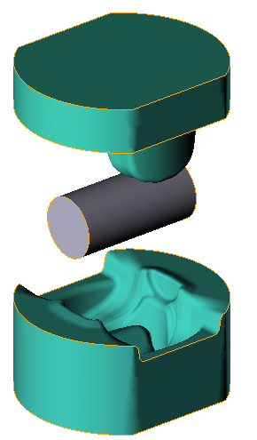  Tools  Lubricant: Graphite + Water  Material: H13 (AISI)  Temperature: 200 ºC  Material: C20 (DIN)  Temperature: 1200°С  Cooling in air: 5 s  Cooling in tool: 2 s  Workpiece  4 mm*  Equipment | 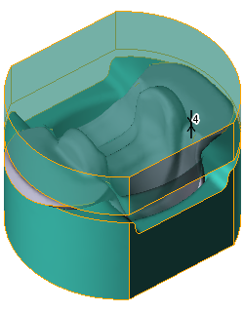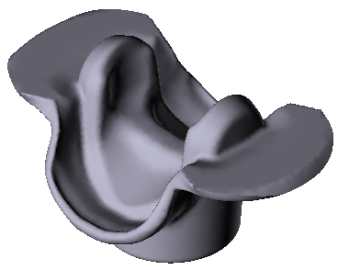
* – by default distance measured between nearest points of tools.

